Project Design Phase-II
Technology Stack (Architecture & Stack)

Date | 19 Febraury 2026
Team ID | LTVIP2026TMIDS41894
Project Name | Plugging into the Future: An Exploration of Electricity Consumption Patterns Using Tableau
Maximum Marks | 4 Marks

Technical Architecture:
The Deliverable shall include the architectural diagram as below and the information as per the table1 & table 2
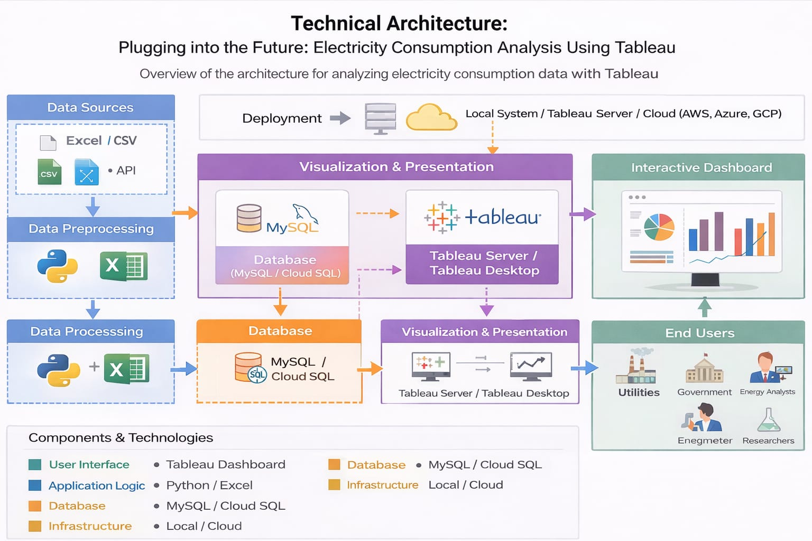

The technical architecture of this project follows a 3-tier model consisting of data sources, data processing, and visualization layers.Electricity consumption data is cleaned and processed before being stored and analyzed in Tableau to generate interactive dashboards for decision-making.

Table-1 : Components & Technologies:
S.No | Component | Description | Technology
1 | User Interface | Users interact through dashboard | Tableau Dashboard (Web UI)
2 | Application Logic-1 | Data cleaning & preprocessing | Python (Pandas) / Excel
3 | Application Logic-2 | Data transformation & calculated fields | Tableau Calculated Fields
4 | Application Logic-3 | Filtering, ranking & aggregation logic | Tableau Analytics Engine
5 | Database | Stores cleaned electricity data | MySQL / CSV
6 | Cloud Database | Optional cloud storage | AWS RDS / Google Cloud SQL
7 | File Storage | Dataset storage | Local File System / Cloud Storage
8 | External API-1 | Government Electricity Open Data | Government Open Data Portal
9 | External API-2 | Weather API (Optional for analysis) | OpenWeather API
10 | Machine Learning Model | Forecasting electricity demand (optional extension) | Python (Scikit-learn)
11 | Infrastructure | Application Deployment | Local System / Tableau Server / AWS Cloud

Table-2: Application Characteristics:
S.No | Characteristic | Description | Technology
1 | Open-Source Frameworks | Libraries used for preprocessing | Python, Pandas, NumPy
2 | Security Implementations | Access control for dashboard | Tableau Authentication, HTTPS
3 | Scalable Architecture | Can handle large datasets | 3-tier Architecture (Data → Logic → Presentation)
4 | Availability | Hosted on cloud or Tableau Server | AWS / Tableau Server
5 | Performance | Fast query processing & filters | Tableau Extract (.hyper), Caching

